MACH4METAL

metalworking machinery
Transito 21,
6909 DA BABBERICH, Netherlands
Tel. + 31 (0)316 – 247123
Fax. + 31 (0)316 - 247956
info@mach4metal.com
www.mach4metal.com

Bank No : 66.52.13.883
IBAN : NL33 INGB 0665 2138 83
BIC : INGBNL2A

FORTE Bandsaw SB 1600 heat exchanger
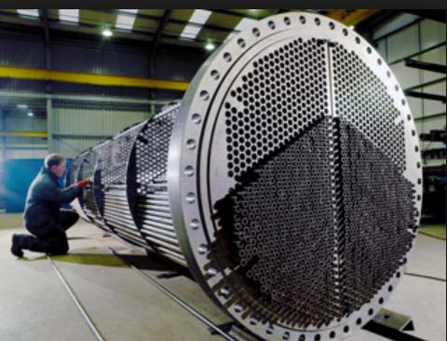
- Make : FORTE Germany
- Type : SB 1800
- Age : 05/78
- Mach.No. : 1180

Sawing Capacity
- Max. Ø : 1800 mm
- Cutting length : 450 mm
- Cutting speed : 10 – 70 M/Min
- Blade size : 8900 x 25 x 0,9
- Power : 6,5 kW
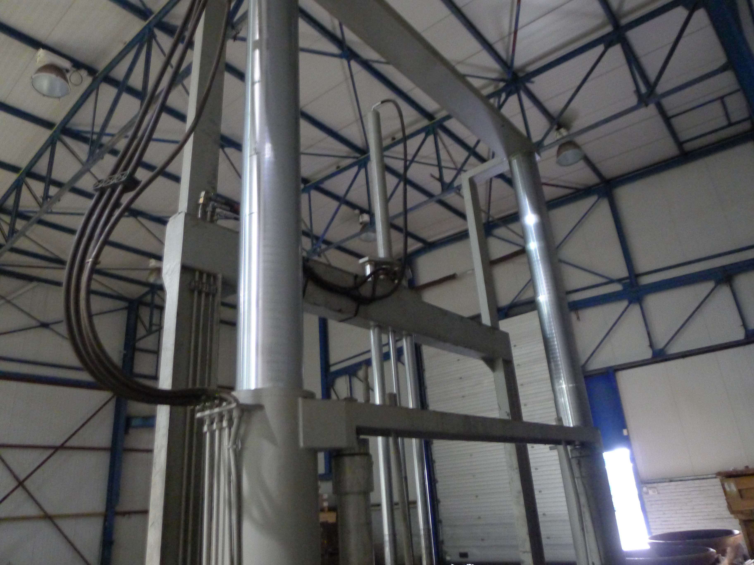
- Dimensions

- Length : 4.230
- Width : 1.950
- Height : 4.060
- Weight : 5.000

- New price EUR 150.000
- Machine for cutting flinches up to 1800 mm
- Machine for cutting pipe end heat exchanger
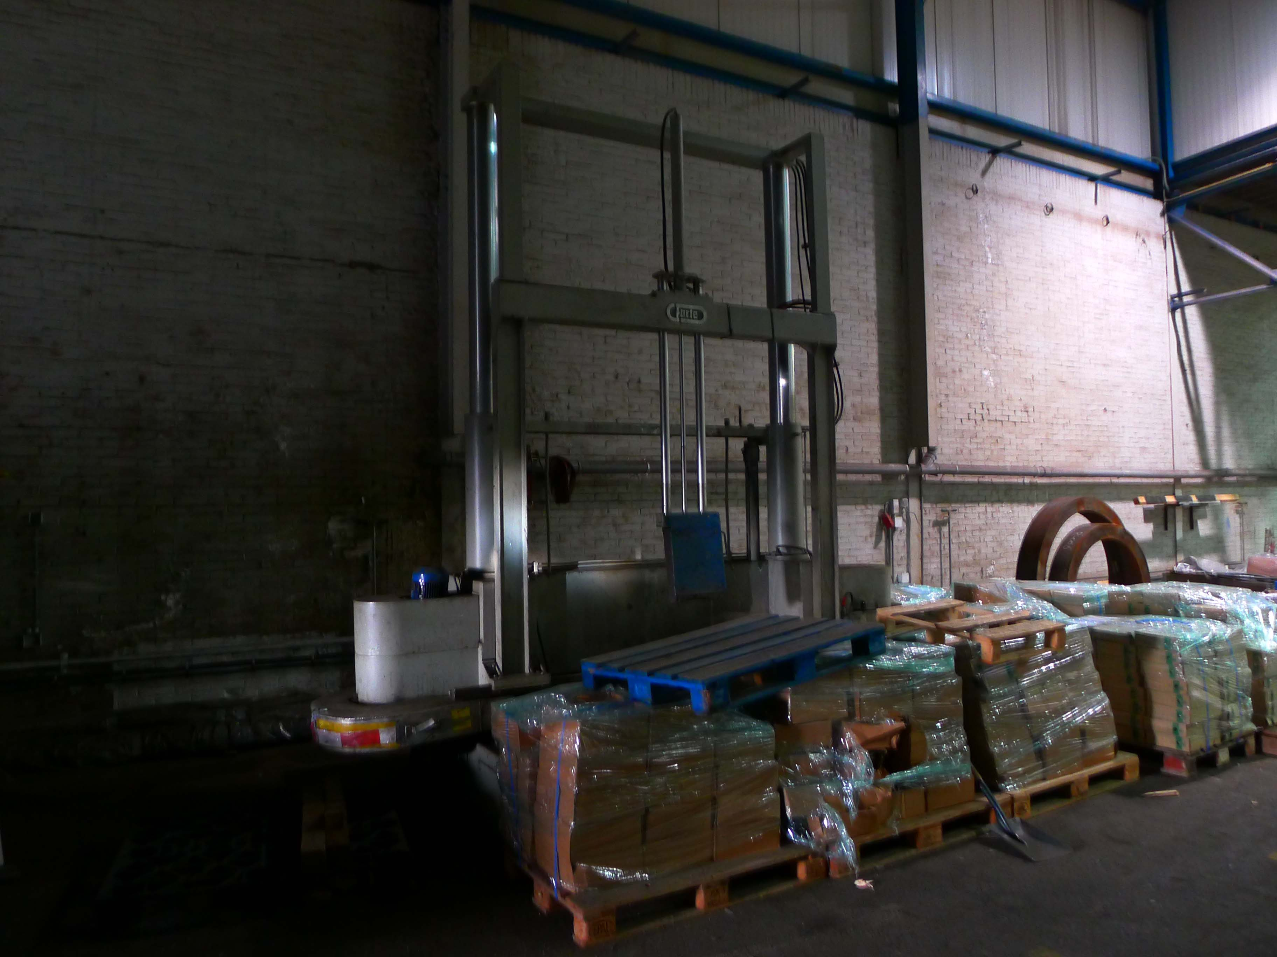

Please Note: The above information has been obtained to the best of our ability and belief from, and from the manufacturers where possible. It is given in good faith, but its accuracy can not be guaranteed. Accordingly, it will not form a representation or constitute contractual terms. We advise you to check any vital deta

